|  |
| --- |
| **Trading on behalf (members procedure)** |

**Summary**

|  |  |
| --- | --- |
| **Objective of the procedure** | ***Describe actions to be taken by SEMOpx members to submit orders in case the submission on behalf procedure is triggered.*** |
| **Concerned persons** | ***SEMOpx members on MRC Day-Ahead markets*** |

**Historical of the document** (Update must be performed after any modification of the process)

|  |  |  |  |
| --- | --- | --- | --- |
| **Historical of modifications** | | | |
| **Evolution** | **Date** | **Version** | **Comments** |
| Creation | 16/01/2018 | 1.0 |  |

Current version must be designated with grey background

**SUMMARY**

1. Introduction 3

2. Business process 3

2.1 Procedure triggering/Email reception 3

2.2 Filling of bidding form 3

2.3 Upload of bidding form 5

2.4 Integration confirmation 5

3. Particular Cases 5

# Introduction

In case a connection issue occurs between ETS Servers and members, SEMOpx Market Operations have the possibility to trigger the Submission On Behalf procedure. In this case, orders will not be placed via the normal ETS client but inserted into ETS via xls bidding forms through customized interface.

Make sure the traders contacts of your company are updated correctly in SEMOpx Database before the procedure.

The process consists in two phases:

* Submission: the orders are transmitted to SEMOpx Market Operations
* Integration: the received orders are integrated into ETS in an automatic mode

# Business process

The submission of orders by members shall correspond to the following business process:



## Procedure triggering/Email reception

As soon as the trading on behalf procedure is triggered, each **authorized trader registered in SEMOpx Database** will receive a customized email containing:

* One hourly and one complex bidding forms (xls files) for each of the market areas they autorised to place orders on.
* A unique URL for the company, which leads to the uploading platform. The URL is the same for all traders of a company so all the bids submitted are visible on the same webpage.
* Instructions for the order submission

## Filling of bidding form

The bidding forms (xls files) attached to the email are customized for each member. Once they have been filled-in, they can be up-loaded through the member interface. The bidding forms are valid for one session of Submission On Behalf only and cannot be used by other members than the one who initially received the email.

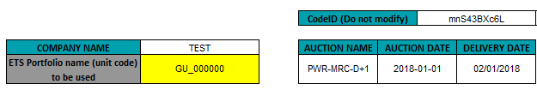

**Company Name:** ETS Shortname is filled in automatically

**Portfolio name (unit code):** Scrolling down menu with the portfolios (unit codes) of the company. Pick up one portfolio (unit code) per file.

**ID code:** Automatically generated for each form. Not to be changed by the trader.

Be careful that all lines of your order are copied and pasted into the bidding form you received, including the price steps line. Make sure you carefully save your xls file before uploading it.

Please note that you need to fill-in and submit:

* **one file per portfolio (unit code) and per market**

(Example: one file for UNIT CODE X in NI-DA).

* **two files if submitting bids on two different portfolios (unit codes) on one market area**

(Example: one file for UNIT CODE X in NI-DA and one file for UNIT CODE Y in NI-DA)

* **four files if submitting bids on two different portfolios (unit codes) on two different market areas**

(Example: one file for UNIT CODE X in NI-DA, one file for UNIT CODE X in ROI-DA, one file for UNIT CODE Y in NI-DA and one file for UNIT CODE Y in ROI-DA)

Please be aware that:

* Several versions of an **hourly order** can be integrated, but each version erases completely the previous version.

**Note on DST days**

For both DST days, the template shall be the same as normal days (i.e. 24 hours templates):

* For DST winter, hour 3a will be automatically replicated on hour 3B when integrating in ETS (contrarily to ETS where hour 3A and 3B bidding is independent)
* For DST summer, hour 3 will be ignored by the system, whether it contains a value or not.

## Upload of bidding form

The URL: included in the email will lead each member to a dedicated interface for bidding forms upload. The interface is compatible with Internet Explorer but is optimized for Firefox.

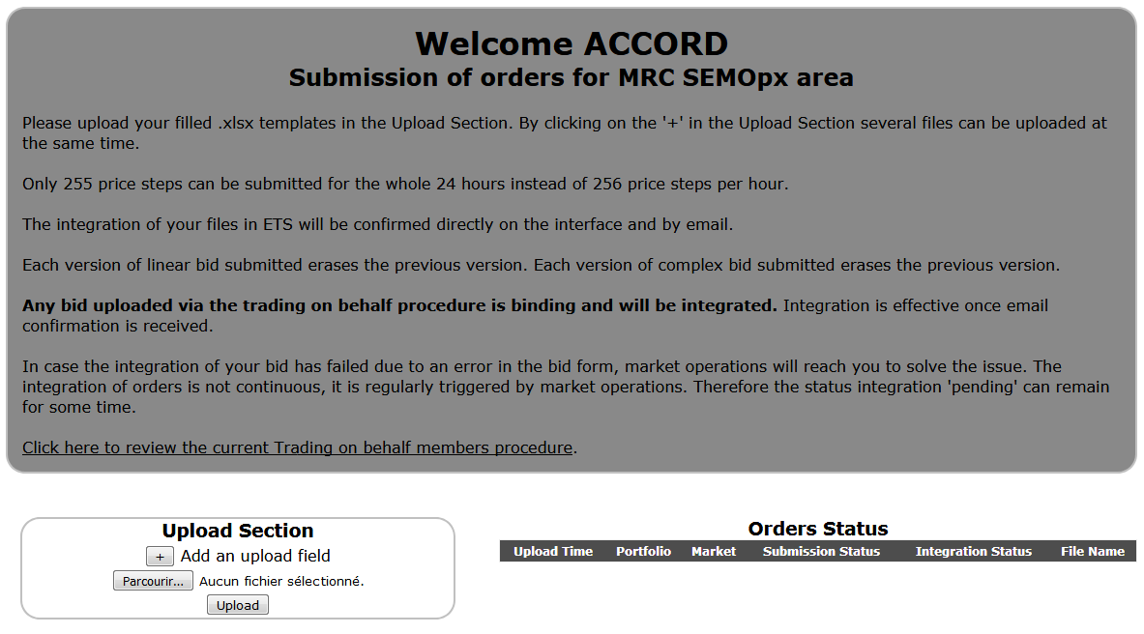

### Upload Section

Sections to upload bidding forms. By clicking on the "+" several upload sections can be added in order to upload several files at the same time. Once file have been selected, click on upload to submit the orders.

The submitted file is checked by the interface, which confirms the submission of the order (not the integration).

### Upload messages

Whether the upload of files is successful or not, the corresponding messages resulting from the latest upload are displayed.

### Order status

For each of the uploaded files, the order status displays the status of the submission and the status of the integration. One line is displayed per file submitted. If one phase has failed, the line will still be displayed.

## Integration confirmation

The integration in ETS is triggered by SEMOpx Market Operation on regular time intervals. It is not a continuous process, so the member interface displays the status “pending” for integration until integration is triggered. Once successful, integration is confirmed by email and on the interface. In case the integration process fails, Market Operation will contact the sender. The integration process is successful only if the order is taken into account for the auction.

# Particular Cases

In case an order is submitted via ETS Client and via the Submission On Behalf tool, the latest order sent erases the previous version. Traders must carefully plan their orders submission, in case they have submitted an order via normal ETS client, a previous trading on behalf order might overwrite it if it is integrated afterwards.

In case you simply want to remove a previous order, please submit an order containing zero value (for the volume).

When the order book is closed, the members interface will display the status accordingly and no more orders can be uploaded.

The previous process for submission on behalf is still available (including templates on SEMOpx website) in case an issue prevents from submitting via the automated interface.

